Feature Engineering and Model Comparison
Task 1 Report

1. Objective
The goal of this task was to prepare the sales dataset for predictive modeling, create meaningful new features, handle missing and categorical data, train more than one model, compare them using appropriate evaluation metrics, and explain which model is preferable and why.

2. Dataset
The same Superstore Sales dataset used in Week 2 was used again, 8,399 rows and 21 columns, so this week's results can be compared directly against last week's baseline. Week 2 trained models on the raw columns only and reached 0.8685 accuracy with a Decision Tree. The aim this week was to see whether adding engineered features improves that.
The target is the same as Week 2: Profitable is 1 when the order line made money and 0 when it lost money. The class balance is close to even at about 49 percent to 51 percent.

3. Handling Missing Values
Only one column has missing data, Product Base Margin, with 63 missing values out of 8,399. These were filled with the median margin of the same product category rather than a single global median, which is more accurate and keeps every sale in the dataset. After this step there are no missing values anywhere.

4. Feature Engineering
Five new features were created. Each is a simple calculation from columns that already exist, but each gives the model something the raw columns do not.
Feature | Formula | Why it was created
Shipping Delay | Ship Date - Order Date | A slow shipment may point to a bulky or awkward product
Revenue Per Unit | Sales / Order Quantity | Separates cheap bulk orders from expensive small ones
Shipping Cost Ratio | Shipping Cost / Sales | Week 2 showed shipping eats margin, this measures it directly
Discount Value | Sales x Discount | 10% off a 5,000 order is very different from 10% off a 50 order
Order Month | Month of Order Date | Lets the model pick up any seasonal pattern

The most important of these is Shipping Cost Ratio. The Week 2 analysis found that Sales and Profit only correlate at 0.58, meaning a large sale does not guarantee a large profit. This feature captures part of the reason why.

5. Checking the New Features Before Training
Before training any model, the new features were checked with boxplots to see whether they actually separate profitable orders from unprofitable ones. If the two boxes overlapped completely, the feature would not be useful and there would be no point including it.
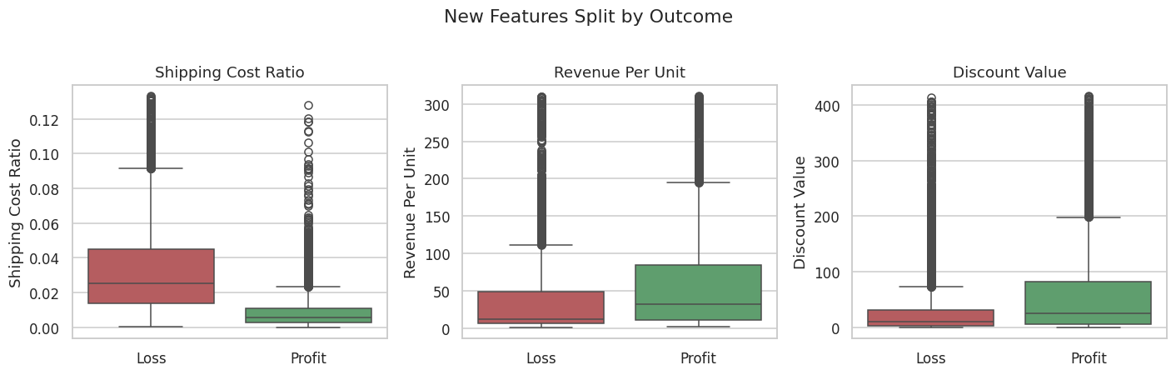
Figure 1: New features split by outcome, tail trimmed at the 95th percentile for readability
Shipping Cost Ratio clearly separates the two groups, with loss-making orders showing a noticeably higher ratio. This is exactly what the Week 2 analysis suggested would happen. Revenue Per Unit also shifts between the groups. This was a good early sign that the feature engineering was worth doing.

6. Preprocessing and Splitting
Profit was dropped from the features because the target is derived from it, so keeping it would give the model the answer. ID columns and free-text names were also dropped because they carry no useful pattern. That leaves 11 numeric features (6 original and 5 new) and 7 categorical features, which become 58 columns after one-hot encoding.
The data was split 80/20 with stratify set to the target so both sets keep the same class balance, and a fixed random_state of 42 so the result is reproducible. Numeric columns are scaled and categorical columns are one-hot encoded inside a Pipeline, which means the transformers are fitted on the training data only and nothing leaks into the test set.

7. Results: Model Comparison
Three models were trained. Logistic Regression is the simple baseline, Decision Tree was the best model in Week 2, and Random Forest is new this week, which is essentially many decision trees voting together.
Model | Accuracy | Precision | Recall | F1 | ROC-AUC
Logistic Regression | 0.8732 | 0.8595 | 0.8875 | 0.8733 | 0.9364
Decision Tree | 0.9310 | 0.9309 | 0.9287 | 0.9298 | 0.9561
Random Forest | 0.9458 | 0.9600 | 0.9287 | 0.9441 | 0.9888

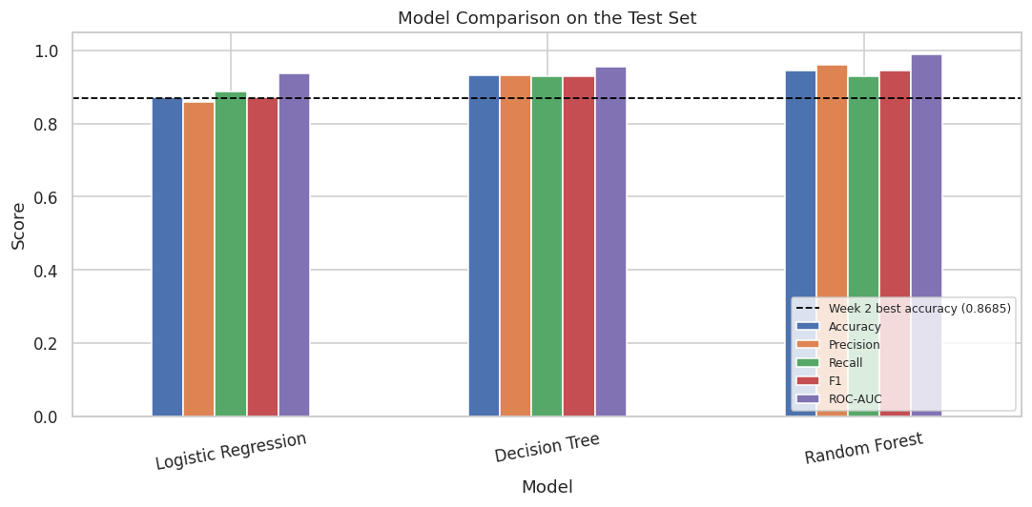
Figure 2: Model comparison, with the Week 2 best accuracy shown as a dashed line
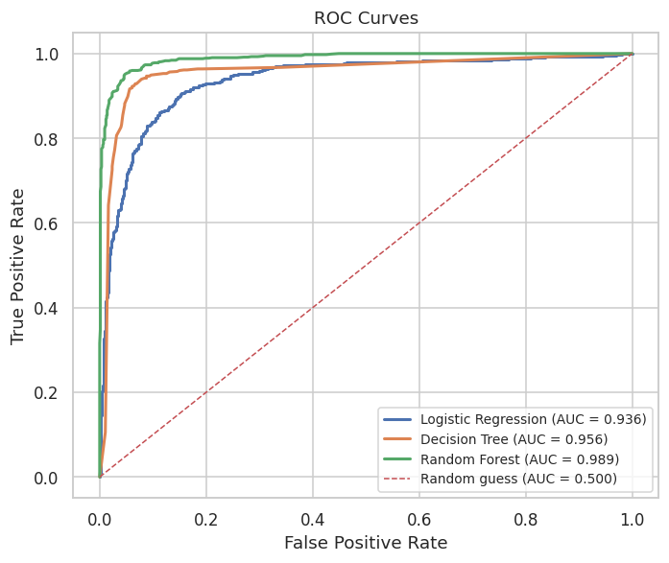
Figure 3: ROC curves for the three models

8. Cross-Validation
A single train/test split can be lucky, so 5-fold cross-validation was run on the training set to check the scores are stable.
Model | Mean Accuracy | Standard Deviation
Logistic Regression | 0.8695 | 0.0058
Decision Tree | 0.9143 | 0.0061
Random Forest | 0.9351 | 0.0082

The cross-validation scores are close to the single-split scores and the standard deviations are small, so the results are stable rather than the product of one lucky split.

9. Did Feature Engineering Actually Help?
It is easy to assume the new features helped just because the score went up. The fair way to check is to retrain the same three models on the original columns only, with the same split and the same settings, and compare.
Model | Original features only | With new features | Improvement
Logistic Regression | 0.7917 | 0.8732 | +0.0815
Decision Tree | 0.9071 | 0.9310 | +0.0239
Random Forest | 0.9405 | 0.9458 | +0.0053

Every model scored higher with the new features. Since the algorithms and the split were identical in both runs, the improvement comes from the features alone.
The size of the improvement is also interesting. It is largest for Logistic Regression and smallest for Random Forest. That makes sense: Logistic Regression can only draw straight lines, so it depends heavily on being handed good features. Random Forest can already find some of these patterns by combining raw columns itself, so the new features add less to it.

10. Detailed Evaluation of the Best Model
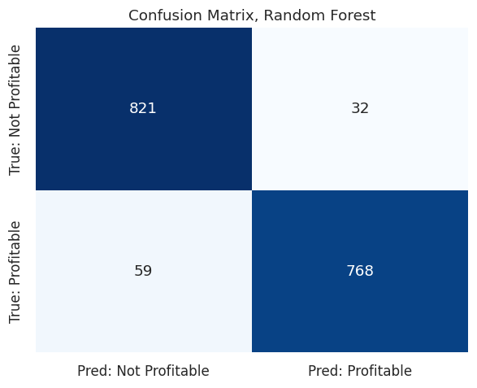
Figure 4: Confusion matrix for the Random Forest model
On the 1,680 test rows, Random Forest produced 821 true negatives, 768 true positives, 32 false positives and 59 false negatives. The 32 false positives are orders predicted to be profitable that actually lost money. The 59 false negatives are profitable orders wrongly flagged as losses, which in business terms would mean turning away good business.
Precision is higher than recall (0.9600 against 0.9287), meaning the model is fairly careful about calling something profitable but misses some profitable orders in the process.

11. Comparison Against Week 2
 | Accuracy | ROC-AUC
Week 2 best: Decision Tree on raw columns | 0.8685 | 0.9296
Week 3 best: Random Forest with new features | 0.9458 | 0.9888

12. Which Model Is Better, and Why
Random Forest was selected, based on three things rather than accuracy alone.
- Scores. It has the highest accuracy, precision, F1 and ROC-AUC of the three models tested.
- Stability. Its cross-validation standard deviation is 0.0082, small enough that the score is not swinging between folds.
- Usefulness for Task 2. Random Forest reports feature importances, which Task 2 needs in order to explain what drives the predictions.
Logistic Regression is the easiest model to explain, since it produces one coefficient per feature, but it is clearly the weakest performer here. That matches the Week 2 conclusion that this problem is not linear, so a model limited to a straight decision boundary cannot capture it.
The trade-off with Random Forest is that 200 trees are much harder to explain than a single tree or a set of coefficients. That is an acceptable cost here because Task 2 uses feature importance to recover most of that explainability.

13. Reflection

What I learned
- Feature engineering made more difference than changing the algorithm. The same three models scored higher purely because they were given better inputs.
- Shipping Cost Ratio came directly from an observation made during the Week 2 analysis, which showed that exploring the data properly before modelling genuinely pays off.
- Retraining on the original columns was the only way to prove the improvement was real rather than assumed. Without that comparison, the higher score would just be a claim.

Limitations
- The dataset has no cost-of-goods column, so profitability can only be estimated from price, discount and shipping.
- The split is random, so two lines from the same order can end up on opposite sides of it. Splitting by order would be more correct.
- No hyperparameter tuning was done, so none of the three models are performing at their best.
- The decision threshold is left at the default 0.5.

Next steps
- Split the data by Order ID instead of randomly, so a whole order always stays on one side.
- Try tuning the Random Forest with GridSearchCV to see how much more it can give.
- Add customer-level features, such as how many orders a customer has placed before.
- Try a time-based split, training on the earlier years and testing on the later ones, which is closer to how the model would really be used.

